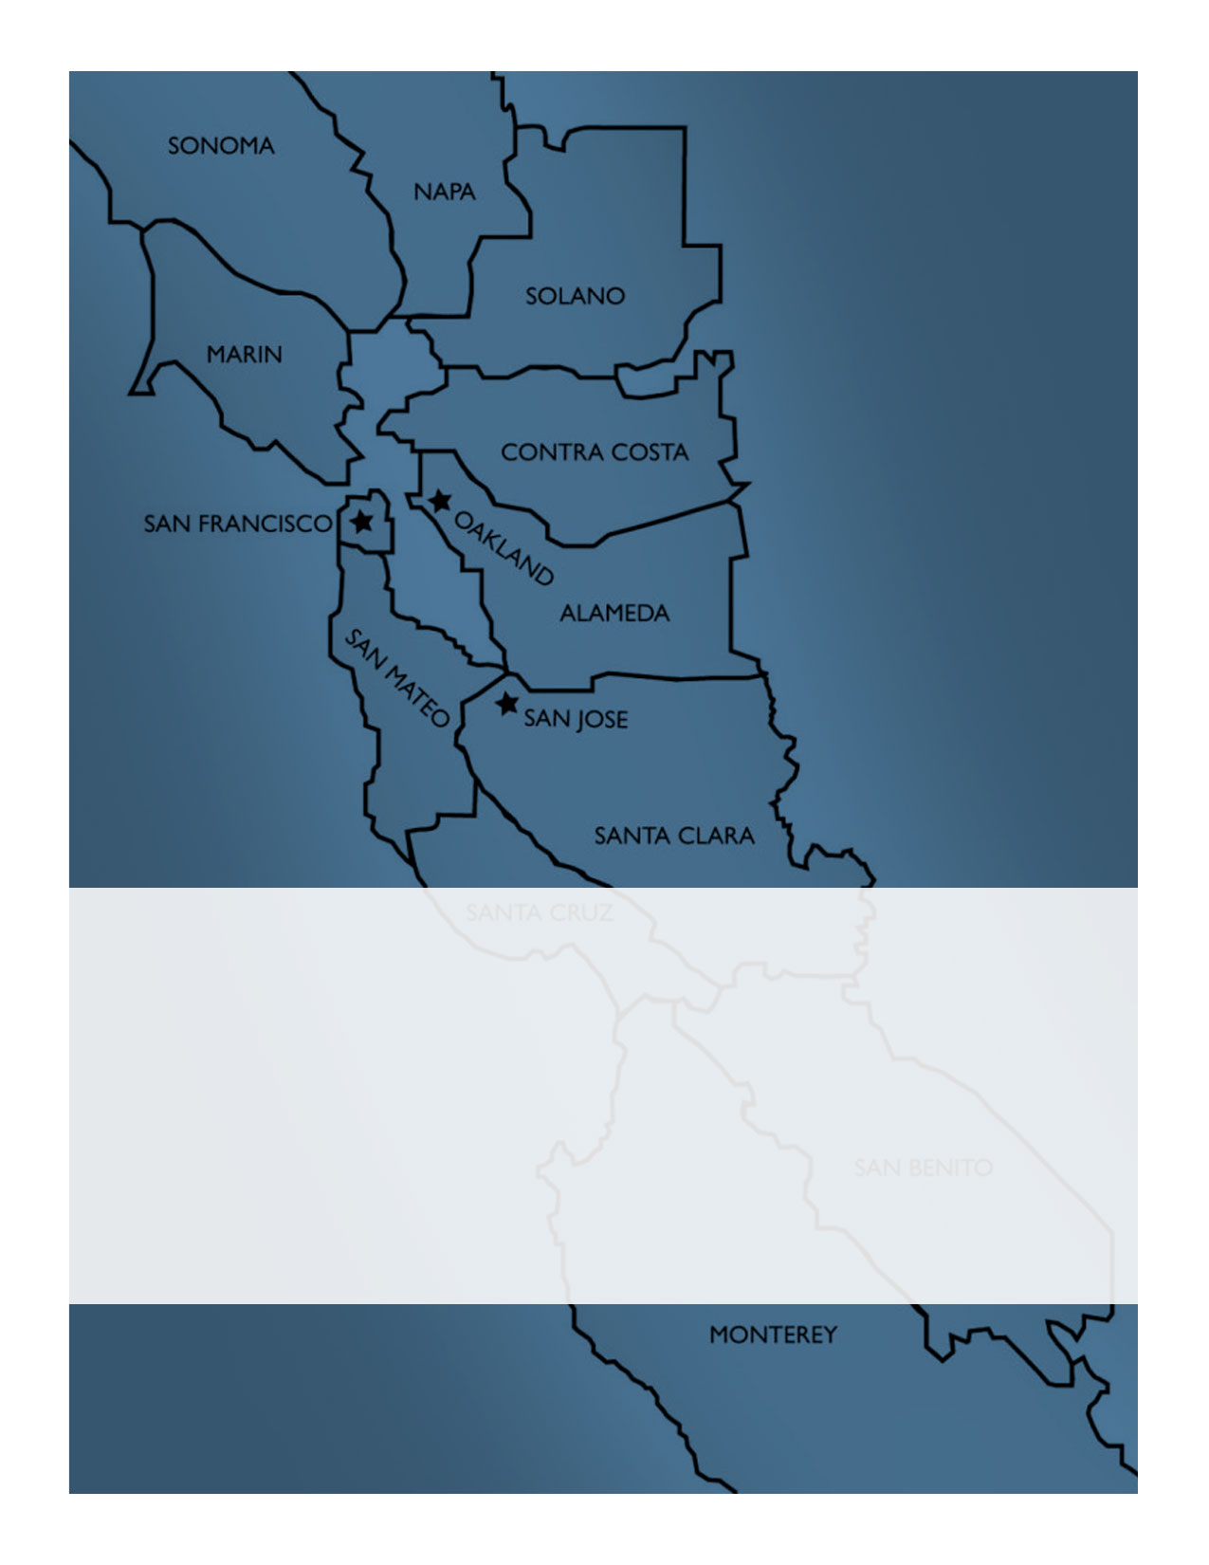


Bay Area UASI
Alert and Warning Toolkit
December 2019 Version 2

Toolkit Overview
This toolkit has been developed in partnership with the Bay Area Joint Information System (JIS) with funding and support from the Bay Area Urban Areas Security Initiative (UASI), and with input and guidance of Alert and Warning program administrators in the Bay Area, and Nusura, Inc.
The purpose of the toolkit is to provide program administrators with tools and resources to craft and disseminate alert and warning messages to the public during emergencies, and to engage other agencies and departments in messaging efforts. Toolkit components are designed to be flexible and customizable to meet the unique needs of agencies or departments. This toolkit is consistent with the State of California Alert & Warning Guidelines, which uses these definitions:
- “A public alert is a communication intended to attract public attention to an unusual situation and motivate individual awareness.
- A public warning is a communication intended to persuade members of the public to take one or more protective actions in order to reduce losses or harm.”
This toolkit is organized in the following manner:
- Part I – Bay Area Alert and Warning Programs – This section includes examples of how Bay Area jurisdictions might structure their Alert and Warning Programs. It contains a comparison between traditional Alert and Warning and Public Information functions. It also includes a link to a contact list of program administrators and Alert and Warning opt-in sign up web pages for Bay Area jurisdictions.
- Part II – Training and Exercising – This section includes guidance in integrating Alert and Warning into local training and exercise plans or calendars. It also has a list of Alert and Warning-related training opportunities and resources.
- Part III – Partnerships with Federal Programs – This section includes Frequently Asked Questions (FAQs) about Integrated Public Alert & Warning System (IPAWS) and an overview of the National Weather Service/Local Jurisdiction Partnership for Non-Weather Emergency Messages.
- Part IV – Alert and Warning Templates and Guidance – This section contains sample Alert and Warning message templates, as well as guidance for developing and disseminating accessible alert and warning messages. It also includes a template for an Alert and Warning Quick Reference Guide for local jurisdiction executives.
- Part V – Non-Weather Emergency Messaging Partnership – This section explains the partnership with the National Weather Service.
- Part VI – Acronyms – This is a list of acronyms found in the toolkit, along with their meanings.
The current copy of this toolkit is available as part of the Bay Area JIS’s shared document repository. Email bayareajis@gmail.com for access to the shared folder and copies of all Bay Area JIS tools and resources.

Contents
Toolkit Overview 2
Part I: Bay Area Alert and Warning Programs 4
Bay Area Alert and Warning Programs Contact List 4
Sample Alert and Warning Models 5
PART II: Training and Exercising 7
Alert and Warning Training Opportunities 7
Sample Training and Exercise Calendar 9
Part III: Partnerships with Federal Programs 11
Alert and Warning Frequently Asked Questions 11
Part IV: Alert and Warning Templates and Guidance 15
Protective Action Message Templates 15
Evacuation Order 15
Evacuation Warning 16
Shelter-in-Place 16
Boil Water Advisory 16
Hazard-Specific Templates 17
Flooding Awareness 17
Hazardous Materials 17
Active Shooter or Assailant 17
Cancelling an Alert 18
Guidance for Accessible Alert and Warning Communications 18
Actionable Tasks 19
Message Delivery Channels 20
Accessible Digital Communications 20
Documentation Preparation 21
Multimedia Guidelines 21
Social Media 21
People Who Have Hearing or Speech Disabilities 22
People Who are Blind or Have Low Vision 22
Website Considerations 22
Public Information and Warning Core Capability Guide 23
Alert and Warning Quick Reference Guide 24
Part V: Non-Weather Emergency Messages Partnership 25
Part VI: Acronyms 26

Part I: Bay Area Alert and Warning Programs

Bay Area Alert and Warning Programs Contact List
JURISDICTION | WEBSITE | OPT-IN SYSTEM(S)
Alameda County | acalert.org | AC Alert (Everbridge)
Contra Costa County | cwsalerts.com | CWS Alerts (AtHoc)
Marin County | https://www.marinsheriff.org/services/emergency-services/alert-marin | AlertMarin (Everbridge)  Nixle
Monterey County | www.co.monterey.ca.us/government/departments-a-h/administrative-office/office-of-emergency-services/ready-monterey-county | Alert  Monterey (Everbridge)  Nixle
Napa County | https://readynapacounty.org/199/Alerts-Notifications | Nixle
San Benito County | http://www.cosb.us/county-departments/oes/ | (CodeRed)
City and County of San Francisco | https://sfdem.org/public-alerts  www.SF72.org | AlertSF (Everbridge)
San Mateo County | https://hsd.smcsheriff.com/smcalert | SMCAlert (Everbridge)
Santa Clara County | https://www.sccgov.org/sites/alertscc/Pages/home.aspx | AlertSCC
Santa Cruz County | https://public.coderedweb.com/CNE/en-US/218A80E36F49 | (CodeRed)  Citizen  Connect
Solano County | http://www.solanocounty.com/depts/oes/alertsolano/information.asp | AlertSolano  (Everbridge)
Sonoma County | https://socoemergency.org/home/emergency/stay-informed/socoalert/ | SoCoAlert (CodeRed)  Nixle

Sample Alert and Warning Models
The Bay Area UASI region is comprised of diverse communities, each with unique alert and warning needs and capabilities. This section outlines a few examples of different models for a local alert and warning program. Jurisdictions may consider these models as they build and update their own alert and warning programs. This toolkit does not promote one organizational model over another.
Program Element | Example 1 | Example 2 | Example 3 | Example 4 | Example 5 | Example 6
Number of staff | One Program Manager  Two Emergency Planning Coordinators | Three Managers  In addition, 11 Emergency Services Coordinators (ESC) are trained on developing and/or sending alerts. | The following staff are trained on developing and/or sending alerts:  9-1-1 Dispatch (PSAP)  - Twelve Supervisors  - One Operations Manager  - One Center Manager  - One Office of Emergency Services (OES) Duty Officer (rotates among four staff)  - One Alert & Warning Coordinator  OES  - One OES Duty Officer (rotates among four staff)  - One Emergency Manager  Four OES staff | 1 Technical Staff  All municipalities with access to opt-in system trained on sending messages  24/7 on call staff to assist with sending alerts | 1 FT Manager  1 FT Emergency Services Coordinator  2 Duty Officers trained to take requests for alerts | 3 Duty Officers with back up available
Staff’s primary function | All three, Full-time (FT) staff are dedicated to the alert and warning program | Three staff are dedicated to the alert and warning program, Monday through Friday (M – F), 0700 – 1600 hours. | No | No | Two FT staff are dedicated to the alert and warning program | No
Program Element | Example 1 | Example 2 | Example 3 | Example 4 | Example 5 | Example 6
Amount of staff time spent on Alert and Warning, including planning and other functions | FT | Eight ESCs rotate week-long shifts; three FT staff are dedicated to the program | Varies | Varies | Varies | Varies
Frequency that staff participate in training and topics | Monthly – Debrief activations and requests; send test alert or alert in test system  Biannually or monthly, plus social science review, roles, responsibilities, etc. | Initial Academy Style Training occurs during onboarding  Biannual Classroom (2 times a year)  Monthly Training  Weekly Case Review  Training Bulletins and Operational Updates, as needed |  | OES staff provides training on request, monthly or every other month. Staff must also take trainings from opt-in system service provider | Web-based training series under development; FEMA courses are required | Training and testing with replicated system
Required approvals for sending alerts | Staff and Duty Officers have the authority to send alerts without any additional approval.  All message content and affected areas information based on request from the Incident Commander (IC). | Day Watch and Duty Officers have authority to send any alert based upon the situation and requests from the IC.  IPAWS initiation must receive authority from DEM Director, Fire Chief, or Police Chief |  | 24/7 On Call Duty Officers have authority to send messages, though WEA and EAS alerts require approval from DEM Executive Director, Police Chief, or Fire Chief. | Six alerting authorities can send alerts. | OES staff are authorized to send alerts.

PART II: Training and Exercising

Alert and Warning Training Opportunities
The Federal Emergency Management Agency’s (FEMA) Emergency Management Institute (EMI) offers multiple trainings on alert and warning. FEMA and its Integrated Public Alert & Warning System (IPAWS) Program Management Office (PMO) also provide information and resources on IPAWS, creating effective messages, and other topics related to alert and warning. This section of the toolkit lists suggested courses and resources for staff with a role in their jurisdiction’s alert and warning program.
- Integrated Public Alert & Warning System (Online Resources)
This website provides general information about IPAWS, a nationwide infrastructure for alert and warning. (https://www.fema.gov/integrated-public-alert-warning-system)
- IS-247.A: IPAWS (Online Training)
This course provides basic information on IPAWS. The goal of this course is to provide authorized public safety officials with increased awareness of the benefits of using IPAWS for effective public warnings; skills to draft more appropriate, effective, and accessible warning messages; and best practices in the effective use of Common Alerting Protocol (CAP) to reach all members of their communities. (https://training.fema.gov/is/courseoverview.aspx?code=IS-247.a)
- IS-248: IPAWS for the American Public (Online Training)
This course provides the American public with an introduction to IPAWS. It identifies the key features and benefits of IPAWS and the authorities responsible for sending alert and warning messages. It also describes protective actions that can be taken before and during an emergency. (https://training.fema.gov/is/courseoverview.aspx?code=IS-248)
- IS-251: IPAWS for Alerting Authorities (Online Training)
This course provides alerting authorities with an increased awareness about Collaborative Operating Groups (COGs), including information about their structure, capabilities, and responsibilities, as well as skills to draft more appropriate, effective, and accessible warning messages using best practices. (https://training.fema.gov/is/courseoverview.aspx?code=IS-251)
- IS-271.A: Anticipating Hazardous Weather & Community Risk, 2nd Edition
(Online Training)
Anticipating Hazardous Weather and Community Risk, 2nd Edition provides emergency managers and other decision makers with background information about weather, natural hazards, and preparedness. This module offers web-based content designed to address topics covered in the multi-day Hazardous Weather and Flood Preparedness course offered by the FEMA and the National Weather Service (NWS). (https://training.fema.gov/is/courseoverview.aspx?code=IS-271.a)

- G-272: Warning Coordination (Classroom Training)
Every year, the United States experiences more severe weather than any other country in the world. In order to reduce deaths, injuries, and property losses, emergency managers must work closely with the NWS and the news media to provide effective warnings that are received and understood by people at risk. The course is primarily designed for local and state government emergency program managers or officials responsible for coordination and communication. Among the topics presented are the social dimensions of warning response, developing effective warning messages, developing an effective community warning process, and working with the news media to create a weather warning partnership. Recommended Prerequisites: IS-271, Anticipating Hazardous Weather and Community Risk, G-271, Hazardous Weather and Flooding Preparedness, and IS-247, IPAWS. (https://www.caloes.ca.gov/cal-oes-divisions/california-specialized-training-institute/general-information/course-schedule)
- Testing with the IPAWS Lab (Online Resource)
The IPAWS PMO provides public safety officials with a controlled IPAWS testing environment where alert and warning technologies can be exercised to assess capabilities and effectiveness. The primary purpose of the IPAWS Lab is for public safety officials to gain confidence using IPAWS in a safe and closed environment. Additional purposes of the IPAWS Lab include alert and warning functional assessment, alert dissemination validation, training, procedural and process evaluation, and the establishment of functional requirements. (https://www.fema.gov/testing-ipaws-lab)
- Modernizing Public Warning Messaging (Online Resource)
In “Modernizing Public Warning Messaging,” Dr. Dennis Mileti presents research on how to design and disseminate alerts and warning information that encourages public action. Dennis Mileti is a retired professor from the University of Colorado at Boulder, where he directed the Natural Hazards Center, a clearinghouse for social science research on hazards and disasters. He has authored more than 100 publications, most of which are on the societal aspects of hazards and disasters. D. Mileti emphasizes that multiple dissemination channels for public disaster warnings yield quicker, more comprehensive audience penetration. (https://www.fema.gov/preptalks/mileti)
- Visual + Effective Communication for Emergency Information (Online Resource)
Claudine Jaenichen, an information designer specializing in the relationship between design and cognition, discusses the cognitive biases that impede the ability to make the right decision in an emergency, and shares effective evacuation maps that will help more people recall safe routes when ordered to evacuate. (https://www.fema.gov/preptalks/jaenichen)
- Advancements in Public Alert & Warning Capabilities for Building Safer Communities (Online Resource)
Learn about tools for supporting IPAWS, and how to integrate the IPAWS data feed into situational awareness and common operating platforms. This resource is offered by the National Alliance for Public Safety GIS Foundation. (https://www.napsgfoundation.org/resources/virtual-training-advancements-in-public-alert-warning-capabilities-for-building-safer-communities/)

Sample Training and Exercise Calendar
The national core capabilities are aligned across five mission areas: Prevention, Protection, Mitigation, Response, and Recovery. FEMA’s National Preparedness Goal identifies 32 core capabilities, including Public Information and Warning which crosses over all five mission areas.
FEMA describes Public Information and Warning as the ability of public officials to:
Deliver coordinated, prompt, reliable, and actionable information to the whole community through the use of clear, consistent, accessible, and culturally and linguistically appropriate methods to effectively relay information regarding any threat or hazard, as well as the actions being taken and the assistance being made available, as appropriate.
A Training and Exercise Plan (TEP) is a document, reviewed and updated regularly, that guides a jurisdiction’s or agency’s successful training and exercise program. The TEP reflects the jurisdiction’s or agency’s overall emergency preparedness priorities. A TEP encourages continual improvement. Training and exercises provide opportunities for jurisdictions or agencies to determine where corrective actions and/or updates to plans may be needed.
As required by state and federal agencies, the TEP must include practicing the jurisdiction’s or agency’s alert and warning capabilities.
The State of California requires that Operational Areas practice their alerting capability in simulated environment or in real time at least twice a year. This may include:
- Receipt and re-transmission of a Required Monthly Test (RMT) based on FCC requirement.
- National Period Test. FEMA will schedule the National Periodic Test yearly.
- Missed Tests. Check for IPAWS OPEN connectivity.
- Test Codes. Time Duration and Jurisdiction Location Codes.
- Test Formats and Scripts. Required weekly test announcements and visual messages.
To retain access to IPAWS services, FEMA requires all alerting authorities to test at a minimum once per month with the IPAWS Lab at Indian Head Maryland. FEMA identifies specific testing requirements in its MOA with the FEMA IPAWS Program Management Office. If an alerting authority misses three months of testing, FEMA will disable that alerting authority’s access to IPAWS, followed by notification to the alerting authority and the State of California.
The table on the following page is a sample calendar focused on Alert and Warning that can be incorporated into an agency’s or jurisdiction’s TEP. Agencies and jurisdictions should review and update this sample to meet their preparedness program needs.

Year | Core  Capability | Training  Exercise | Jan | Feb | Mar | Apr | May | Jun | Jul | Aug | Sep | Oct | Nov | Dec
Year | Core  Capability | Training  Exercise | QUARTER 1 |  |  | QUARTER 2 |  |  | QUARTER 3 |  |  | QUARTER 4
Year 1 | Public  Information  and Warning | Training | IS-247.a (online)  Completion required within this quarter |  |  | IS-248 (online)  Completion required within this quarter |  |  | IS-251 (online)  Completion required within this quarter |  |  | IS-271.a (online)  Completion required within this quarter
Year 1 | Public  Information  and Warning | Exercise | IPAWS  test  (monthly) | IPAWS  test  (monthly) | IPAWS  test  (monthly) | IPAWS  test  (monthly) | A&W  Workshop | IPAWS  test  (monthly) | IPAWS  test  (monthly) | IPAWS  test  (monthly) | Regional  PI and  A&W FE | IPAWS test (monthly) | A&W TTX | IPAWS  test  (monthly)
 |  |  |  |  |  |  | IPAWS  test  (monthly) | IPAWS  test  (monthly) | IPAWS  test  (monthly) | IPAWS  test  (monthly) | IPAWS  test  (monthly) | IPAWS test (monthly) | IPAWS  test  (monthly) | IPAWS  test  (monthly)
Year 2 | Public  Information  and Warning | Training | G-272  (Classroom-based; Schedule  during Q1) |  |  |  |  |  | IPAWS  Lab  Testing
Year 2 | Public  Information  and Warning | Exercise | IPAWS  test  (monthly) | IPAWS  test  (monthly) | A&W  Drill | IPAWS  test  (monthly) | IPAWS  test  (monthly) | IPAWS  test  (monthly) | IPAWS  test  (monthly) | IPAWS  test  (monthly) | Regional PI and A&W FE | IPAWS test (monthly) | A&W FSE | IPAWS  test  (monthly)
 |  |  |  |  | IPAWS  test  (monthly) |  |  |  |  |  | IPAWS test (monthly) | IPAWS test (monthly) | IPAWS  test  (monthly) | IPAWS  test  (monthly)
Sample Training and Exercise Calendar for Alert and Warning

Part III: Partnerships with Federal Programs

Alert and Warning Frequently Asked Questions

What is Alert and Warning?
According to the State of California Alert & Warning Guidelines:
- A public alert is a communication intended to attract public attention to an unusual situation and motivate individual awareness.
- A public warning is a communication intended to persuade members of the public to take one or more protective actions in order to reduce losses or harm.

What is an alerting authority?
Public officials are granted the authority to alert the public of emergency situations through federal, state, and local laws. These are designated in a local Federal Communication Commission (FCC) Emergency Alert System (EAS) Plan, and within a signed FEMA Memoranda of Understanding.

What is the Emergency Alert System?
The EAS is used by alerting authorities to send warnings via broadcast, cable, satellite, and wireline communications pathways. EAS participants, consisting of broadcast, cable, satellite, and wireless providers, are the stewards of this important public service in close partnership with alerting officials at all levels of government. The EAS is also used when all other means of alerting the public are unavailable; it provides an added layer of resilience to available emergency communication tools.

What are Wireless Emergency Alerts?
Wireless Emergency Alerts (WEAs) were established pursuant to the Warning, Alert, and Response Network (WARN) Act under FCC rules. Alerting authorities can broadcast WEAs to cellular carrier customers with compatible mobile devices located in the geographic vicinity of cellular towers serving an affected area. WEAs are used to send concise, text-like messages to WEA-capable mobile devices during emergency situations.

How does my organization send WEAs to the public?
Through a partnership between the FCC, FEMA, and commercial mobile service providers, alerting authorities are able to use The Integrated Public Alert & Warning System (IPAWS) to send WEAs, even when cellular networks are overloaded and can no longer support person-to-person calls, texts, or emails. The IPAWS is accessed through software that meets IPAWS system requirements.

What is IPAWS?
IPAWS is the Integrated Public Alert and Warning System that was established in 2006 by Presidential Executive Order 13407. In the event of a national emergency, the US president will be able to use the IPAWS to send a message to the American people quickly and simultaneously through multiple communications pathways.
IPAWS is also available to U.S. federal, state, local, territorial, and tribal government officials to alert the public via the EAS, the Commercial Mobile Alert System/Personalized Local Alert Network, National Oceanic and Atmospheric Administration (NOAA) Weather Radio, and other National Weather Service (NWS) dissemination channels.

What are the benefits of using IPAWS?
IPAWS automates and streamlines the process of issuing public alerts. Using IPAWS, Collaborative Operating Groups (COGs) are able to send an alert to multiple dissemination channels at the same time. IPAWS also enables the exchange of private alerts between government agencies that need to communicate about an emergency.

What is a Collaborative Operating Group (COG)?
A Collaborative Operating Group (COG) is a term used by the IPAWS to designate an organization that is responsible for coordinating emergency management or incident response activities. COGs consist of individual members who may represent one or more disciplines or organizations. COGs may be organized at the national level (e.g., the NWS), multi-state level (e.g., regional mutual aid organization), state level, tribal level, multi-county level, single-county level, single municipality, or single agency. Although COGs are usually formed by government, private-sector representatives may also be COG members.

How do I sign up to participate in IPAWS?
- Step One - Obtain software from a vendor that has a Memorandum of Agreement (MOA) with FEMA for the purpose of testing.
- Step Two – To apply for IPAWS access, send an email to IPAWS@fema.dhs.gov, with the subject line “COG Application.” Complete the MOA application process with IPAWS to establish a collaborative operating group (COG). See http://www.fema.gov/emergency/ipaws/aggregator.shtm#3 for eligibility and instructions.
- Step Three – Once the COG process is completed and you have received a digital certificate, coordinate with your vendor or system administrator to configure your software to work with IPAWS.
Additional requirements for access to IPAWS-OPEN 3.0 for public alerting authorities are in development and will include testing and training components.
A sponsoring organization (e.g., a local government) completes a brief application for a Memorandum of Agreement with FEMA governing system security. See: http://www.fema.gov/media-library/assets/documents/112266. A custom MOA is prepared and returned to the applicant for signature. Once approved by FEMA, you will receive your COG ID number, COG name, and digital certificate. These are necessary to configure the system, so that alerts are properly routed to and from an organization.

Is IPAWS secure?
IPAWS messages include a digital signature built into the system that guarantees the integrity of messages. Messages cannot be tampered with after they are sent. IPAWS has established rules of behavior that offer added security guidance for message originators.

Is IPAWS reliable?
The IPAWS-OPEN system is built for maximum reliability, including a significant increase in bandwidth over the old system, with active back up in regionally separated US Department of Homeland Security IT facilities.

What does it cost?
There is no cost to send messages through IPAWS. However, there is a cost to acquire software to send alert messages. The software is available from several vendors. FEMA does not endorse the product of any company, but provides a list of vendors that have executed MOAs to test standards-compliant equipment and software.
See http://www.fema.gov/pdf/emergency/ipaws/open_developers.pdf
Agencies may also wish to consult with their current software system provider to determine if the tools they are currently using are already or will be compatible with IPAWS in the future. Existing local warning systems may also be configured to work with IPAWS by private sector system integrators; any customization costs are the cost of the end user.

Does IPAWS replace the systems I already have in place?
The use of IPAWS is optional, and may supplement an agency’s existing systems; however, IPAWS is the only means of accessing the Commercial Mobile Alert System and Personal Localized Alerting Network (CMAS/PLAN) to disseminate warnings to cellular telephones.

What technology do I need to send messages through IPAWS?
Agencies need to have computer software that can create IPAWS-compliant messages. These tools are being developed by a variety of private companies (costs vary based on licenses, features, etc.). Agencies also need a reliable Internet connection.

Who is required to complete the FEMA EMI IS-247.A IPAWS online training?
The primary point of contact for the COG and any other COG members who can transmit public alerts from your software system are required to complete the training. Primary points of contact are required to submit a copy of their certificate of completion as part of the application process. Training records for all other members must be maintained locally by the COG.

What is the FEMA IPAWS supplied part of the system?
FEMA IPAWS is furnishing the message authentication and message aggregation pieces for Common Alerting Protocol / Emergency Alert System (CAP / EAS). Alerting officials can compose a CAP message using any of a number of authoring tools. The message originator's credentials will then be verified and the message will be posted to the aggregator. Properly constructed messages then will be available for retrieval by CAP-enabled EAS devices for broadcast and cable operators. The CAP / EAS device will perform a text-to-speech conversion of the message content if the originator has not included an audio message for broadcast. CAP messages sent to the aggregator will also be passed to Commercial Mobile Service Providers for the Commercial Mobile Alert System (CMAS), which can deliver a 90-character message to all compatible handsets logged into cellular towers serving an affected area.

What type of grants or funding assistance can FEMA provide to help purchase or acquire IPAWS-compliant equipment?
The IPAWS PMO office provides this link (http://www.fema.gov/government/grant/hsgp) to the 2011 Homeland Security Grant Program (HSGP) and the associated IPAWS 2011 HSGP Supplemental Guidance. This information is provided to assist state, territorial, tribal, and local governments with preparing documentation for the acquisition of common alert protocol (CAP), compliant public alert and warning equipment, as well as training, exercise, and alert and warning outreach activities. Funding from the HSGP, Tribal Homeland Security Grant Program (THSGP), and the Emergency Operations Center (EOC) Grant Program can be used to enhance existing or establish new alert and warning programs.
Presently, FEMA does not provide grants to private entities and/or businesses. FEMA encourages the latter to coordinate their requests with their Statewide Interoperable Coordinator (SWIC), the Statewide Interoperability Governing Body (SIGB), and/or the appropriate stakeholders at the state, territory, tribal, and local levels of government. FEMA also encourages interested parties to review posted entries at http://grants.gov for additional possible funding opportunities.
Contact the IPAWS PMO at ipaws@dhs.gov prior to initiating alert and warning program activities with any questions.

Does IPAWS support social media for emergency alerts?
IPAWS-compliant software may be able to create an alert “news feed” from an IPAWS account that can be used to populate social media.

Part IV: Alert and Warning Templates and Guidance
Drafting messages for high-probability hazards before an incident occurs can help maximize the timeliness and success of related alerts and warnings. Messages should give clear information on the emergency situation and/or direction on protective actions to be taken by public.
Alert and warning messaging consist of five main components:
- Source: Who the message is from establishes authority and credibility with intended recipients. The public needs to know the message is coming from a credible, trusted source.
- Hazard/Threat: Identify the threat and its (potential) impacts.
- Location: The message must identify and describe the impacted area in a way that can be easily understood (e.g., street names, landmarks, natural features, political boundaries).
- What-To-Do-Guidance: Message recipients should know exactly what to do within seconds of receiving and reading the alert. Use direct, plain language that is not panic-inducing. Words and phrases such as “evacuate” and “shelter-in-place” are common in today’s public vernacular, and can be incorporated into a variety of general and hazard-specific templates.
- Time: This confirms what is happening and when. It helps to establish the validity and stage of the emergency so that message recipients understand the impacts of what is happening now, what has happened, and what they may be able to expect as a result of the emergency.

Protective Action Message Templates

Evacuation Order
- Overview: This message is used to order immediate evacuation.
- Alert Title / Subject: Alert: Evacuation Order Due to {Incident type} at {Incident Location}
- Short Text: (INSERT AGENCY NAME): Evacuate immediately due to a (INSERT INCIDENT TYPE) at (INSERT INCIDENT LOCATION).
- Long Text: This is an urgent message from (INSERT NAME OF AGENCY). Alert: Evacuate immediately due to (INSERT INCIDENT) at (INSERT INCIDENT LOCATION). If you are receiving this message and are within (INSERT AFFECTED AREA) of (INSERT INCIDENT LOCATION), you need to evacuate the area immediately. An evacuation site is available at (INSERT EVACUATION CENTER). Gather other residents, pets, and critical medications and leave the area. If it is safe to do so, please check with neighbors to ensure they are aware of this alert and to see if they need assistance. If it is difficult for you to evacuate, please contact INSERT CONTACT), close doors and windows, and turn off any heating or A/C. A further update will be sent by (INSERT ETA OF NEXT UPDATE) or sooner, if conditions change. (INSERT ADDITIONAL INFO.)

Evacuation Warning
- Overview: This message is used to encourage the public to be prepared for an evacuation within approximately two hours, if necessary. People who may have difficulty evacuating due to transportation, medical, or mobility constraints should consider relocating immediately, since they may not have sufficient time if or when an evacuation order is issued.
- Alert Title / Subject: Alert: Prepare to Evacuate. (INSERT INCIDENT TYPE) at (INSERT INCIDENT LOCATION).
- Short Text: Prepare for possible evacuation due to (INSERT INCIDENT TYPE) at (INSERT INCIDENT LOCATION).
- Long Text: This is an urgent message from (INSERT AGENCY NAME). Alert: There has been (INSERT INCIDENT TYPE) of incident at (INSERT INCIDENT LOCATION). If you are receiving this message and are within (INSERT AFFECTED AREA) of (INSERT INCIDENT LOCATION), please prepare for possible evacuation. Gather other residents, pets, medications, and important papers. Be prepared to evacuate at a moment's notice. If it is safe to do so, please check with neighbors to ensure they are aware of this alert and to see if they need assistance. If it is difficult for you to evacuate due to transportation, medical, or mobility constraints, consider evacuating the area now. A further update will be sent by (INSERT ETA OF NEXT UPDATE) or sooner, if conditions change. (INSERT ADDITIONAL INFORMATION).

Shelter-in-Place
- Overview: This message tells the public it is necessary to shelter in place. This may be needed in weather events, hazardous material incidents, etc.
- Alert Title / Subject: Alert: Shelter in place. (INSERT INCIDENT TYPE) at (INSERT INCIDENT LOCATION).
- Short Text: Shelter in place due to (INSERT INCIDENT TYPE) at (INSERT INCIDENT LOCATION).
- Long Text: This is an urgent alert from (INSERT AGENCY NAME). Alert: There has been a INSERT INCIDENT TYPE) at (INSERT INCIDENT LOCATION). If inside, remain indoors, close doors and windows, and turn off any heating or A/C. If outdoors, move away from (INSERT AFFECTED AREA) or seek refuge indoors. A further update will be sent by (INSERT ETA OF NEXT UPDATE) or sooner, if conditions change. (INSERT ADDITIONAL INFORMATION).

Boil Water Advisory
- Overview: This message tells the public to boil water before using. It may be needed during and/or after a public health, weather, hazardous materials incidents, etc.
- Alert Title / Subject: Alert: Boil Water Advisory for (INSERT IMPACTED AREAS).
- Short Text: Boil water due to (INSERT INCIDENT TYPE) at (INSERT INCIDENT LOCATION).
- Long Text: Boil Water Advisory. Bring tap water to a rolling boil, boil for one minute, and cool before using, or use bottled water. Boiled or bottled water should be used for drinking, making ice, washing dishes, brushing teeth, and preparing food until further notice. This Boil Water Advisory applies to (INSERT LOCATION). Routine monitoring on (INSERT DATE) showed inadequate disinfection of your drinking water. Harmful microbes in drinking water can cause diarrhea, cramps, nausea, headaches, or other symptoms, and may pose a particular health risk for infants, some elderly, and people with severely compromised immune systems.
If you experience any of these symptoms and they persist, seek medical advice and care. (INSERT ADDITIONAL INFORMATION).

Hazard-Specific Templates

Flooding Awareness
- Overview: This message is used to tell the public there is imminent flooding in the area.
- Alert Title / Subject: Alert: Flooding predicted at (INSERT INCIDENT LOCATION).
- Short Text: The National Weather Service is predicting flooding for (INSERT INCIDENT LOCATION).
- Long Text (Option 1): The National Weather Service is predicting flooding in (INSERT LOCATION) within the next 24 hours. Residents who live in this area should be prepared to evacuate at any time. Information on how to prepare to evacuate can be found at (INSERT INFO.).
- Long Text (Option 2): This is (INSERT NAME OF AGENCY), reporting a mandatory evacuation order for (INSERT LOCATION) due to potential flooding. Take the following protective actions and leave immediately: 1) Gather all family members or other individuals.
2) Gather pets. 3) Gather only essential items. 4) Be sure to take essential medications with you. 5) Turn off all appliances and lights. 6) Lock your home. The evacuation route is: (INSERT EVALUATION ROUTE). An Evacuation Center is open at (INSERT NAME AND LOCATION OF EVAC CENTER). (INSERT ADDITIONAL INFORMATION).

Hazardous Materials
- Overview: This message tells the public there has been a hazardous materials incident in their area.
- Alert Title / Subject: Alert: Hazardous Materials Incident at (INSERT LOCATION).
- Short Text: A Hazardous materials incident has occurred at (INSERT LOCATION).
- Long Text: There has been a (INSERT SPILL/RELEASE) of a hazardous material at (INSERT INCIDENT LOCATION). If you are in the vicinity, prepare immediately for possible evacuation. Stay away from the affected area. All others should avoid the area so emergency units can work unimpeded. Follow instructions from local authorities. (INSERT ADDITIONAL INFORMATION).

Active Shooter or Assailant
- Overview: This message tells the public there is an imminent life safety threat due to an active shooter.
- Alert Title / Subject: Alert: Active Shooter Incident reported at (INSERT LOCATION).
- Short Text: Active shooter at (INSERT LOCATION). Avoid Area or Run, Hide, Fight. Expect updates.
- Long Text: This is (INSERT NAME OF AGENCY) reporting an active shooter near (INSERT LOCATION). Avoid the area. If you are near (INSERT LOCATION) take the following protective measures: 1) Go inside immediately and stay there until further notice. 2) Bring pets indoors, but only if you can do so quickly. 3) Close and lock all windows and doors and stay away from windows. 4) Call 911 immediately if you have a true emergency or hear or see any suspicious activity in or near your location. You will be advised when your safety is no longer at risk. (INSERT ADDITIONAL INFORMATION).

Cancelling an Alert
- Overview: This message is used when a recently sent alert needs to be quickly canceled because the alert was sent in error or conditions suddenly changed, making the alert either unnecessary or potentially detrimental.
- Alert Title / Subject: Alert: Cancelling (INSERT TITLE) Alert
- Short Text: CANCELLING the (INSERT TITLE OF ALERT). Apologies for any confusion.
- Long Text: This is an urgent message from (INSERT NAME OF AGENCY). Cancelling the (INSERT NAME OF ALERT). Apologies for any confusion. (INSERT ADDITIONAL INFORMATION)


Guidance for Accessible Alert and Warning Communications
The Whole Community, including people who have disabilities or access and functional needs (AFN), should be able to receive and use alert and warning messages. Effective, accessible preparedness messaging can be particularly helpful to people with AFN who may require more time to shelter in place or may need assistance if an evacuation is advised. The goal is to ensure that emergency communication is equally accessible and effective for everyone.
At the state level, the Cal OES Office of Access and Functional Needs (OAFN) coordinates with federal, state, and local partners to ensure communication needs are identified and addressed during disasters. The OAFN maintains a comprehensive library of resources, from guidance documents to sample plans.
The table that follows includes reminders for communicating effectively with audience with different communication needs. In addition to the practices listed in the table, an important part of communicating effectively is to consider the nature, length, complexity, and context of the communication and the person’s normal method(s) of communication.

Table 1. Means of Messaging by Audiences
AudienceS | Means of Messaging
People who are deaf or hard of hearing | Television – captioning and sign language; scrolling text and crawl messages that do not reduce the size of images
People who are deaf or hard of hearing | Press Conferences, Public Meetings – signage; sign language interpreter in full view.
People who are deaf or hard of hearing | Telephone - telephone handset amplifiers, hearing-aid compatible telephones, text  Telephones (TTYs), videophones, captioned telephones, other voice, text, and video-based telecommunications products. Scrolling text must include telephone numbers.
People who are blind or have low vision | Flashing television news updates must include voiced reports.
People who are blind or have low vision | All scrolling text must be read aloud, including telephone numbers and web addresses.
People who are blind or have low vision | Print, Web – Alternative formats (reverse type, such as white text on black background or black type on white background; option to increase type size.)
People who are blind or have low vision | Meetings should include a qualified reader; information in large print, Braille, or in digital form for use with a computer screen-reading program; or an audio recording of printed information.
People with limited English proficiency | Broadcast and print language translation services  Universal directional symbols  Use graphics to illustrate words

Accessibility Checklist
The following checklist provides considerations, guidance, and tools to communicate with people with AFN, including, but not limited to people with disabilities and people with limited English proficiency.

Actionable Tasks
Develop culturally capable messages.
- Colors (Colors may convey different meanings for different groups, religions, cultures, and communities.)
- Art (Images should reflect targeted audiences.)
- Paper (Some may have difficulty reading certain colors.)
- Access (Consider physical distribution points and height placement of messages to enable easily accessible materials.)
- Buy-In (Communicate why this matters to them.)
- Language (The message’s language should be written for audience appropriateness, i.e., age, culture.)
- Evaluation (Help readers or listeners to understand the impact of changes.)

Message Delivery Channels
Channels for delivering messages are varied and will depend on availability, accessibility, and how well they reach populations. Delivery channels, when electricity has not been affected or limited, can include:
- Mass media (television, radio, newspaper)
- Ethnic media
- Podcast
- Internet
- Radio
- Satellite radio
- Your Community Network
- National Oceanic and Atmospheric Administration Weather Radio All Hazards (NWR)
- 2-1-1 or 3-1-1 website
Delivery channels during a blackout or when electricity is not available to all areas could include:
- Cell phone/text messaging
- Battery-powered radio
- NOAA Weather Radio
- Reverse 9-1-1
- Battery-powered walkie talkies
- 2-1-1 telephone
- Ham radio networks
- Telephone calling trees/networks (using landline phones that do not require electricity)
- Door-to-door information (door hangers and pamphlets)
- Information distribution to a pre-determined emergency information point (churches, libraries, grocery stores, post offices, schools, restaurants, markets, shelters)
- Peer ambassadors designated to help neighbors receive information
Emergency management tools to reach diverse populations may include:
- Picture books
- Braille and alternative language handouts
- Closed-captioned videos
- Audiotapes

Accessible Digital Communications
- Develop or provide accessible formats to disseminate alerts and information.
  - Use a variety of formats (text, audio, video, image).
  - Use a variety of methods of information dissemination (broadcast, wireless, internet, social media, apps).
  - Consider various devices (cell phones, tablets, computers, TVs, radios).
- Use software/hardware solutions and interoperable networks.
  - Receive alert feeds from multiple sources.
  - Transition to a next generation 9-1-1 system.

Documentation Preparation
Follow these guidelines to make content accessible to a wider range of people with access and functional needs and all audiences, in general:
- Use system fonts
- Make forms electronically fillable
- Choose an accessible technology platform
- Present text as text
- Include alternative text
- Use styles
- Include tables of contents
- Use short titles in headings
- Use logical heading order
- Use meaningful hyperlink text
- Increase visibility for colorblind viewers
- Use simple tables
- Avoid repeated blank characters
- Avoid floating objects
- Create Closed Captions
- Print flies in large text
- Battery-powered radio

Multimedia Guidelines
Multimedia refers to any presentation that contains more than one type of media. Multimedia typically includes both audio and visual information. For accessible multimedia, consider these options:
- Provide visual representations of audible elements for people who are deaf or hard of hearing.
- Include text transcripts for posted videos or multimedia presentations.
- Text equivalent for every non-text element.
- Audio descriptions of all visual information.
- YouTube will automatically caption the text on videos

Social Media
Social media message relies on its accessibility to individuals who receive the messages. Use the following guidelines to effectively share messages on social media:
- Place #hashtags or @mentions at the end of the tweet.
- Avoid using unfamiliar acronyms.
- Use “CamelCase” (upper and lowercase) for multiple words in hashtags.
- If your post contains photos, video, or audio, use prefixes for people who use screen readers.
- Make your post serve as a description caption by providing context for video or audio element.
  - Include all photo and video descriptions.
  - Provide a link back to the organization webpage that hosts an accessible version of that photo or video.
  - Rather than uploading videos directly to each platform, upload videos to YouTube and enable closed captions.
  - Post YouTube video links to other platforms as status updates. This will ensure that visitors will be taken to the accessible version on YouTube.

People Who Have Hearing or Speech Disabilities
- Telecommunication Relay Service (telephone service that allows people with hearing or speech disabilities to place and receive telephone calls)
- Text-to-Voice TTY-based TRS
- Voice Carry Over (VCO)
- Hearing Carry Over (HCO)
- Speech-to-Speech (STS)
- Shared Non-English Language Relay Services
- Captioned Telephone Service (CTS)

People Who are Blind or Have Low Vision
- Convert written documents to audio conversion.
  - Record materials into an audio file or onto a CD or DVD.
- Consider document text for screen readers use.
- Convert paper documents into Braille.
  - Compose the information in a Microsoft Word-accessible document.
  - Import your document into Braille translation software.
  - Use a Braille embosser.

Website Considerations
- Ensure webpages have appropriate metadata descriptions (i.e., text equivalent to every image).
- Always provide documents in an alternative text-based format (HTML or RTF [Rich Text Format]).
- Websites should be designed with the color and font sizes set in users’ web browsers and operating systems.
Users with low vision must specify the text and background colors, as well as the font.

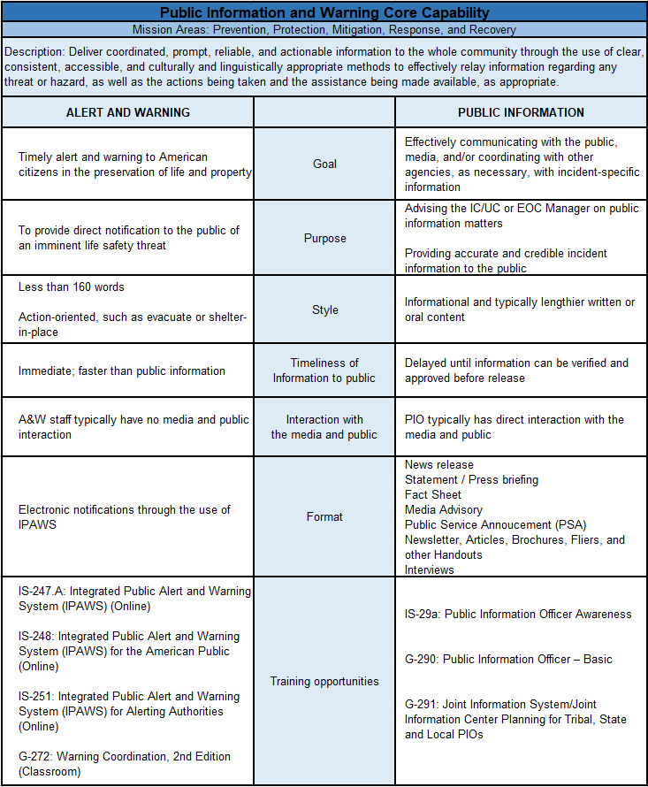
Public Information and Warning Core Capability Guide
Alert and Warning Quick Reference Guide
What is an Alert? | A communication intended to attract public attention to an unusual situation and motivate individual awareness
What is a Warning? | A communication intended to persuade the public to take one or more protective actions to reduce losses or harm.
What is the Integrated Public Alert and Warning System, or IPAWS? | A system that unifies the U.S. Emergency Alert System (EAS), National Warning System (NWS), Wireless Emergency Alerts (WEA), Commercial Mobile Alert System (CMAS), and NOAA Weather Radio under a single platform.
Who does IPAWS reach? | IPAWS reaches the public. IPAWS integrates the aforementioned systems across many communications pathways to ensure the public receives life-saving information during an emergency.  Alerts will be delivered across multiple pathways, including AM/FM/satellite radio; broadcast/cable/satellite TV; NOAA all-hazards weather radio; internet-based applications such as email, instant messaging, and RSS feeds; and emergency telephone networks, voice sirens, and digital road signage.
Consider sending  an alert or warning  via IPAWS when: | Your message  may include: | Your Activation Contact is your Agency's: | Alert Origination Tools: | Tools to Amplify Alerts & Warnings | The reach of these platforms includes individuals with access to:
The public should be informed of an unusual incident or potentially hazardous situation.  The situation is imminent and life threatening  The public must be provided with instructions.  Other warning methods would be ineffective. | The specific location of the hazard, using intersections, streets, or other clear signifiers  A brief description of the hazard  The intended audience  Recommended emergency protective actions  The expected duration of the incident | Alert Originator:  ___________  Contact Info:  ___________ | EAS  WEA  NOAA Radio  Reverse 911  Sirens/Speakers  NOAA Weather Radio  Other(s): | Social Media  Non-government Notification Systems  Community Provider Call Down List  Other(s):  ___________ | Broadcast, cable, and satellite television  Internet web-based applications  AM, FM, Satellite, and NOAA weather radio  Telephones  Text messages on enabled mobile phones and pagers  Digital road signage  Sirens

Alert and Warning Quick Reference Guide

Part V: Non-Weather Emergency Messages Partnership
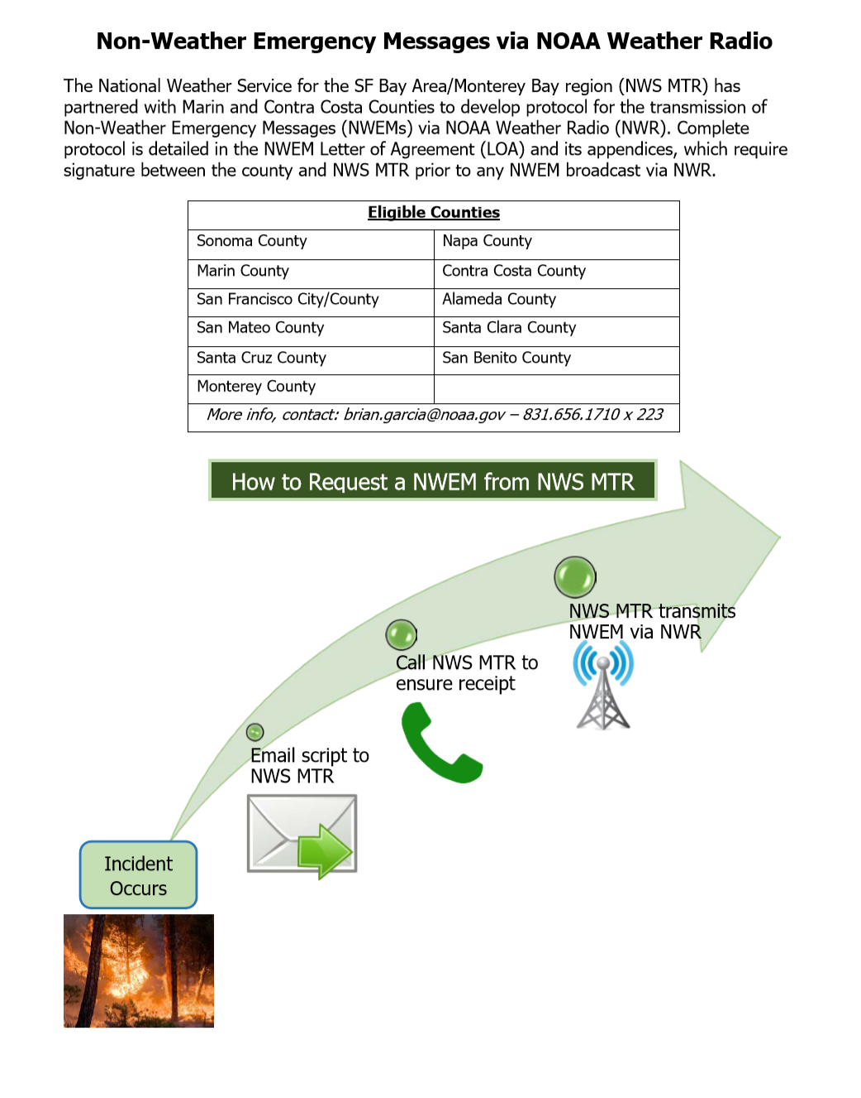

Part VI: Acronyms
Below are common emergency management and Alert and Warning-related acronyms.
ACRONYMS
AFN | Access and Functional Needs
ANI | Automatic Number Identification
ANSI | American National Standards Institute
ASL | American Sign Language
AWARN | Advanced Warning and Response Network
CAP | Common Alerting Protocol
CDW | Civil Danger Warning
CEM | Civil Emergency Message
CFR | Code of Federal Regulations
CMIP | Common Management Information Protocol
CMRS | Commercial Mobile Radio Service
COG | Collaborative Operating Group
CONELRAD | Control of Electromagnetic Radiation
CPG | Comprehensive Preparedness Guide
CPU | Central Processing Unit
CSEEP | Chemical Stockpile Emergency Preparedness Program
CSRIC | Communications Security, Reliability and Interoperability Council
DHS | U.S. Department of Homeland Security
EAS | Emergency Alert System
EMA | Emergency Management Agency
EMI | Emergency Management Institute
EOP | Emergency Operations Plan
ESRI | Environmental Systems Research Institute
ETNS | Emergency Telephone Notification System
FCC | Federal Communications Commission
FEMA | Federal Emergency Management Agency
FIPS | Federal Information Processing Standard
GIS | Geographic Information System
GUI | Graphical User Interface
ACRONYMS (CONTINUED)
HAZCOLLECT | All-Hazards Emergency Message Collection System
HSDL | Homeland Security Digital Library
HSGP | Homeland Security Grant Program
HSEEP | Homeland Security Exercise and Evaluation Program
ICS | Incident Command System
ID | Identification
IEEE | Institute of Electrical and Electronics Engineers
ILEC | Incumbent Local Exchange Carrier
IPAWS | Integrated Public Alert and Warning System
IPAWS-OPEN | IPAWS Open Platform for Emergency Networks
IPT | Integrated Process Team
IT | Information Technology
ITB | Invitation to Bid
JITC | Joint Interoperability Test Command
LAE | Local Area Emergency
LAN | Local Area Network
LEW | Law Enforcement Warning
LP | Local Primary (station)
MOA | Memorandum of Agreement
MOU | Memorandum of Understanding
NENA | National Emergency Number Association
NRF | National Response Framework
NIMS | National Incident Management System
NOAA | National Oceanic and Atmospheric Administration
NTP | Network Timing Protocol
NWEM | Non-Weather Emergency Message
NWS | National Weather Service
OS | Operating System
OSI | Open Systems Interconnection
P2P | Peer-to-Peer
PA | Pubic Address
PC | Personal Computer
ACRONYMS (CONTINUED)
PEP | Primary Entry Point
PMO | Program Management Office
POTS | Plain Old Telephone System
REPP | Radiological Emergency Preparedness Program
RFB | Request for Bid
RFP | Request for Proposal
RMT | Required Monthly Test
RWT | Required Weekly Test
SECC | State Emergency Communications Committee
SIGB | Statewide Interoperability Governing Body
SNMP | Simple Network Management Protocol
SOP | Standard Operating Procedure
SP | State Primary (station)
START | Study of Terrorism and Responses to Terrorism
SWAT | Specialized Weapons and Tactics
SWIC | Statewide Interoperable Coordinator
TAR | Tone Alert Radio
TEP | Training and Exercise Plan
TDD | Telecommunications Devices for the Deaf
TDL | Test Development Lab
THSGP | Tribal Homeland Security Grant Program
UL | Underwriters Laboratories
URL | Uniform Resource Locator
VoIP | Voice Over Internet Protocol
WEA | Wireless Emergency Alerts
XML | Extensible Markup Language

Based on feedback from alerting authorities across the United States and work conducted by the IPAWS Subcommittee to the National Advisory Council, FEMA is combining IS-247a and IS-251 courses to reflect current advances in emergency notification and warning. Anticipated by the end of 2019, the new IS-247b will provide introductory information on IPAWS, its benefits, and instruction for developing and disseminating effective public warnings. The material from IS-251 is also being updated to emphasize skills necessary to draft more appropriate, effective, and accessible warning messages; best practices in effective use of the CAP; and geo-targeting specific areas in communities.
Federal Emergency Management Agency. (2019). Core Capabilities. Retrieved 8/6/2019 from: https://www.fema.gov/core-capabilities
The Homeland Security Exercise and Evaluation Program (HSEEP) is the federal government’s methodology for the design, development, execution, and evaluation of exercises. There are two categories of exercises within HSEEP: discussion-based and operations-based exercises. Discussion-based exercises include seminars, workshops, tabletop exercises (TTX), and games. Operations-based exercises include drills, Functional Exercises (FE), and Full-Scale Exercises (FSE). HSEEP takes a building block approach to exercise development to effectively test an organization’s plans, functions, and capabilities.
Mileti, D. (2018). PrepTalks: Dr. Dennis Mileti “Modernizing Public Warning Messaging.” Retrieved 8/5/2019 from: https://www.fema.gov/media-library/assets/videos/159069#
ADA Best Practices Tool Kit for State and Local Governments, Chapter 5: Website Accessibility Under Title II of the ADA (https://www.ada.gov/pcatoolkit/chap5toolkit.htm)

